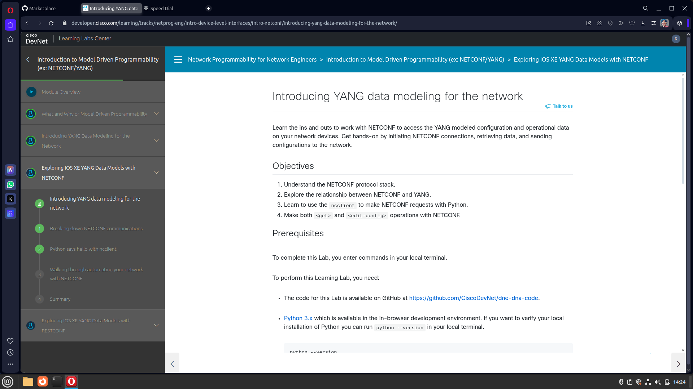
D

1.- Connection is made via ssh

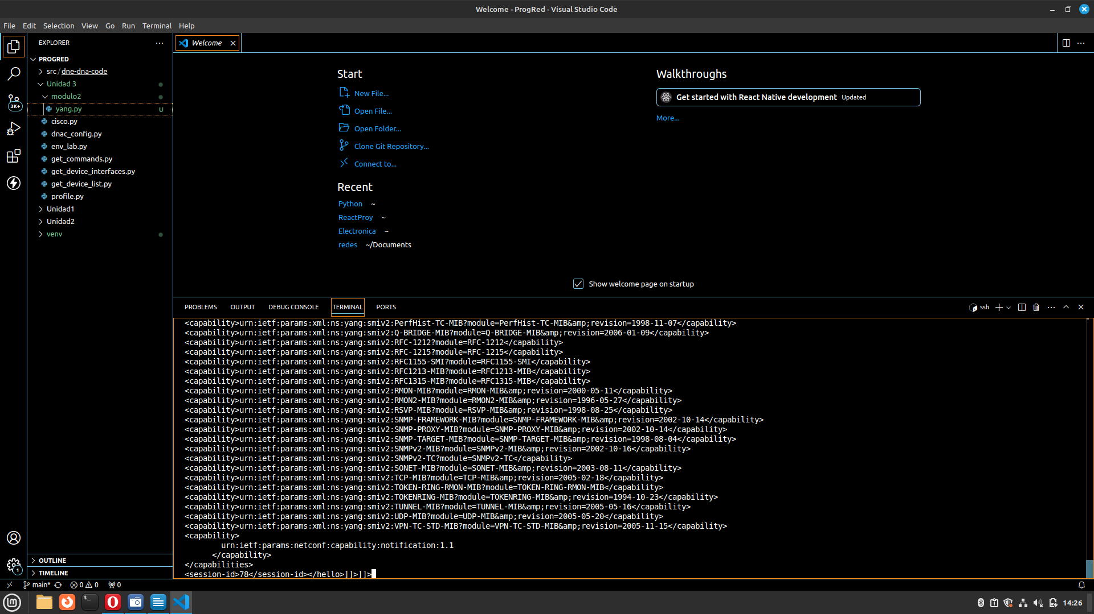
d

2.- Now use: ssh admin@devnetsandboxiosxe.cisco.com -p 830 -s netconf <password is: C1scio12345>
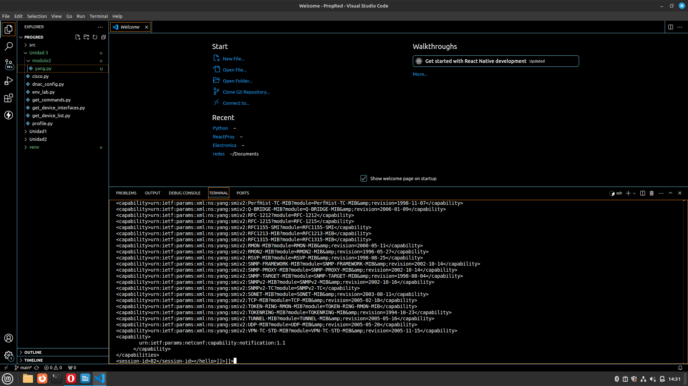
d

3.- We continue the following steps to clone a repository and make a connection which did not work due to the version

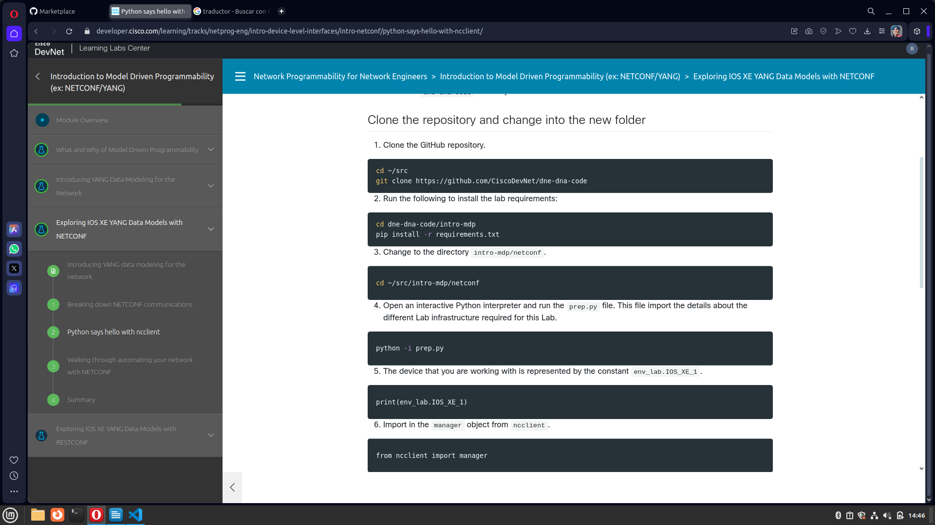
d

4.- It lets me make the connections but it doesn't give me permission since the credentials changed

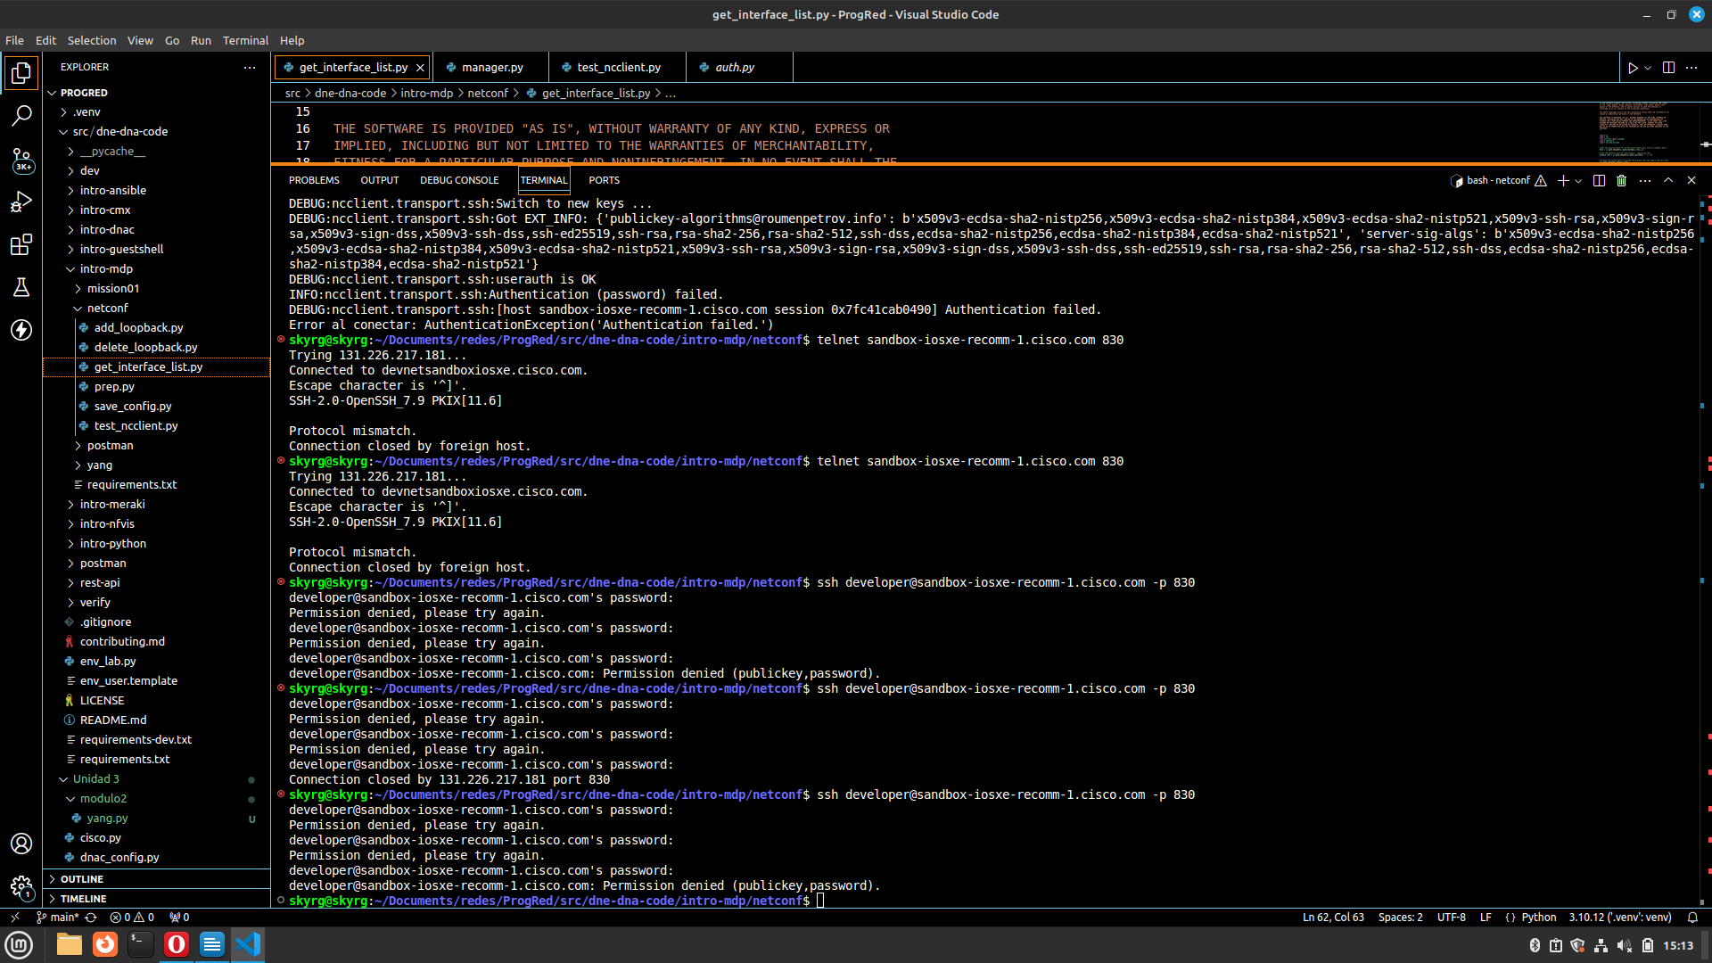
5.-Some tests are carried out in postman but because the connection through the credentials does not work, these cannot be carried out

